Table of Contents

**Next release Fixes Updates** 2

**Getting Ready for 2025** 2

**TurboCASH Updated install script** 2

***Default install theme*** 2

***Added AppCondig settings*** 3

***TurboCASH Version*** 3

***Removed about 20 blank lines in all tcash.ini files*** 3

**Document layout file** 3

**Readme.txt android** 3

Tutorials Updated 3

Calendar Resource name in Updated 4

**Fixes in Previous Merge release** 4

**Themes** 4

***Languages updated*** 4

**MSSQL - Set default language** 4

Unicode install and nounicode setting 4

***Unounicode=false*** 4

***Unounicode=true*** 5

Outstanding - Known issues – Current release 6

***Colours Select for Reporting groups*** 6

***Customise Languages - Rest tab - Empty account / Empty Group*** 6

*Language inconsistencies* 7

No Confirmation Messages 7

**Budgets MSSQL Error** 9

**Access control** 9

***Posting / Delete buttons*** 9

***Default language for a Set of Books*** 9

**Access Violations - Reports** 10

***Ledger analyser - Balance sheet*** 10

***Graphs*** 10

***Cost centres*** 10

**Export - Accounts** 10

***Spreadsheet import - Accounts*** 10

***Import Stock*** 10

**Imported Batches** 10

**Bank import - Import Bank statement** 11

***Delete Bank account with Posted transactions*** 11

***Bank-Import Open Item link*** 11

**Imported Documents** 11

***Import Exported documents*** 11

***Financial entry*** 11

***Update Documents*** 11

**Next release Fixes Updates**

**Getting Ready for 2025**

TurboCASH5 is based on osFinancials5.1.0.189. It is based on Delphi 12 (Upgraded from Delphi 10 / Delphi 11)

**Latest Release** : osFinancials / TurboCASH version 5.1.0.227

**TurboCASH Updated install script**

**Location** : F:\TC5-2025-MERGE-Install\Languages

Updated 140 tcash.ini files in the install languages folder for each country.

***Default install theme***

Updating 140 tcash.ini files in the installation languages folder for each country, you’re ensuring consistency across all installations. Changing the default install theme from theme=3 (Material) to theme=7 (Material navy) provides a fresh look. This means that any new installations will now default to the Material Navy theme, improving the visual experience for all users.

Ensuring that previous installations of TurboCASH5 also respect this theme change by updating their settings is a great move to maintain a consistent user interface. This attention to detail will likely be appreciated by users who value a cohesive look and feel in their TurboCASH5 software.

Users may change the appearance of the TurboCASH5 interface by selecting available themes on the **Themes** menu (**Setup** ribbon). Users may personalise their TurboCASH5 interface by selecting from available themes on the **Themes** menu (**Setup** ribbon) makes the experience more enjoyable and tailored to individual preferences.

***Added AppCondig settings***

Added some specific configurations to the tcash.ini file for TurboCASH5:

* **nounicode=FALSE**: This enables Unicode support, which might be necessary for TurboCASH5 to handle a wide range of characters from different languages, ensuring proper display and processing of multilingual text.

The Unicode settings as set during the installation process will confirm the **FALSE** setting or set it to **TRUE** based on the selected installation options. The **nounicode=TRUE** setting will disable Unicode support, which might be necessary for compatibility with certain older databases or systems that don't fully support Unicode.

* **;BIDIMODE=RTL**: This setting, likely intended to enable Right-to-Left text display, is currently commented out with a semicolon (;). If you want to enable RTL mode, you'll need to remove the semicolon at the beginning of this line. This is useful for languages like Arabic and Hebrew.
* **OB1BOX=False**: This setting likely controls a specific feature or option within TurboCASH5. Setting it to **False** disables that feature.

These settings can help customise the behaviour of TurboCASH5 to better fit your needs.

***TurboCASH Version***

Changed the TurboCASH5.2 version to TurboCASH5-2025 in the 140 tcash.ini files to avoid confusion with previous TurrboCASH5.2 installations.

All 140 tcash.ini files can be changed in one go within minutes when necessary, using Notepad++ - Search and Replace in files in the inno installation languages folder.

***Removed about 20 blank lines in all tcash.ini files***

This will allow for better display in the Preview pane of the File Explorer to view the tcash.ini files before opening it.

**Document layout file**

TRN_906277.rep Document layout file (15 code) Moved the Document type in the Header to the centre as printing to much to the right of the layout file.

**Readme.txt android**

In TurcoCASH5 root directory but not in osfinancials5 root installation directory

Deleted file in TurboCASH5 install as Android app never took off (discontinued)

# Tutorials Updated

All tutorials - Added the Compressor and Drill press images to Stock items for tutorial and documentation purposes.

These images were not included, since these tutorials was created from scratch on a blank database.

Scheduled for next installs compile.

# Calendar Resource name in Updated

Changed the resource shipped in the Calendar from

osFinancials to TurboCASH5 in Tutorials shipped with TurboCASH5

**Fixes in Previous Merge release**

**Themes**

Fixed VS210 Theme to display Classic icons to be consistent with Previous releases of TurboCASH / osFinancials

Checked and updated Background pictures in themes to use the TurboCASH branding in Background images.

***Languages updated***

Fixed typo in Afrikaans language file

LabelID 337 Verskafferreoere => Verskafferretoere missing "t".

Scheduled for next installs compile.

**MSSQL - Set default language**

In MSSQL the **Apply** button does not save the language if selected in Access control for user but works in Firebird.

Replicates the error in osf5.1.0.227 with the Install nounicode setting

*"Invalid object name 'OPREPORT'."*

Cannot open MSSQL all books in both in osFinancials5.1.0.227 and in osFinancials5.1.0.189. This error has to do with the nounicode setting is set to false in the osf.ini file.

*nounicode=false.*

Changing the nounicode setting in the osf.ini file to true, then all MSSQL Sets of Books can be opened:

*nounicode=true*

In osFinancials5.1.0.227, the Unicode settings is implemented in the install. Instead of editing the Unicode settings in the osf.ini file using a text editor, you can set the Unicode settings in the install.

# Unicode install and nounicode setting

Need to wait for clarification to change the “Select Additional Components” screen in the installation script

***Unounicode=false***

If you check both the Unicode and Unicode Check tick-boxes, the Unicode setting will be set as false in the osf.ini file:

*nounicode=false*

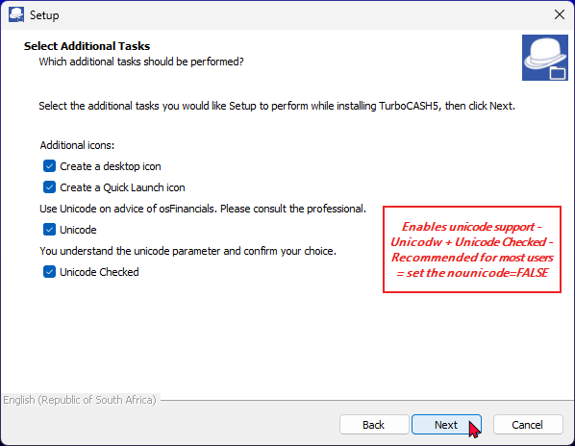

This will cause the MSSQL error, when opening a Set of Books (MSSQL database type).

***Unounicode=true***

If you do not check the **Unicode** checkbox (leave blank) and only select (tick) the **Unicode Checked** tick-box, the Unicode setting will be set as false in the osf.ini file:

*nounicode=true*

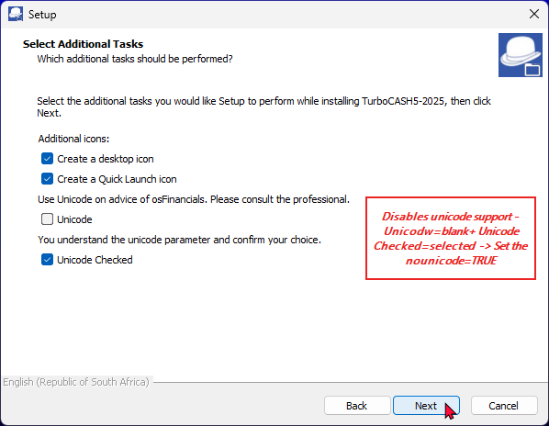

This will resolve the MSSQL error, when opening a Set of Books (MSSQL database type). Can open all Set of Books (MSSQL database type).

# Outstanding - Known issues – Current release

***Colours Select for Reporting groups***

**Setup → Groups**

Setting Colous in Groups does not change easily - MSSQL databases is more sticky than in Firebird databases

Cannot set the Account group 1 colours - Loses selected colours

Standard Theme palette - Hard colours - Cannot make softer colours using Custom colours

Debtor groups, Creditor groups, Document groups and Stock groups works but sticky - If the grids is open, you may select **Tools → Close active forms** and access the grid to display the colours.

***Customise Languages - Rest tab - Empty account / Empty Group***

Replicated in both Firebird and MSSQL databases.

The **Customise languages - Rest** tab does not store "*Groups empty account*" when you click on the **Change** button (second button).

It displays "*Empty account*" from the first "*Description of Zero account*". It does not save correctly.

Difficult for translations or customisation.

Need to change the first **Change** button and confirm to change it to for example no group have to enter "*No group"* and click **Change** (second button). Thereafter need to reopen the Set of Books for changes to have an effect.

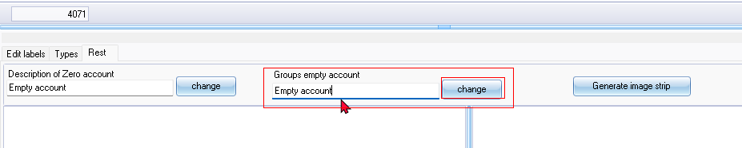

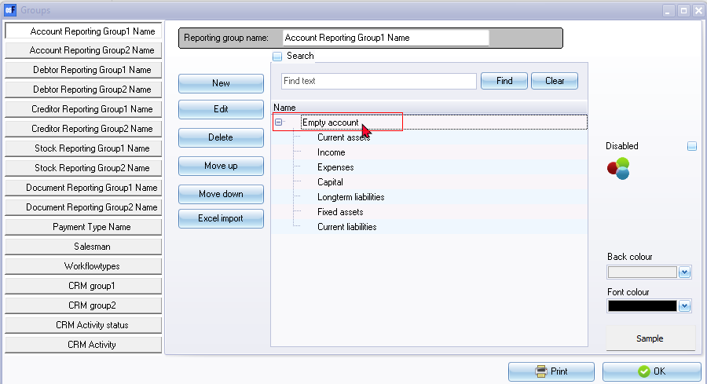

## *Language inconsistencies*

#### Receipt / Receipts

Bank import plugin it refers to Receipt LabelId 1100 used for Receipt. Receipts label ID 2233 is used in other screens such as Receipts journal and label ID 2232 such as Payments journal.

Receipt LabelId 1100 is in the singular form, changing this label, causes Receipts to display when the Print receipt option is used.

This label in the Receipt column may need to be changed in the osFinancials5.exe to be consistent with the Payments column.

This will resolve issues relating to other language dialects, such as Afrikaans, French, Spanish, etc.

Receipts options (LabelID 1314) title bar caption is changed in the language file to Receipt options since this options screen is used to generate a single transaction and print a receipt.

This inconsistency can lead to confusion in other language dialects like Afrikaans, French, Spanish, etc.

#### Document Status - Open

Open uses the same Label as is used in Open buttons. The LabelID could be  LabelID 163,,  LabelID 20120 or LabelID 20142  - The document status for Open documents is Unconfirmed in Documents grid.

 In the Document entry form's header refers to Open (LanguageID's 163, 20120 or 21042)., which is used for the Open button on most screens. There is LabeID 580, Open for posting. Unposted (LabelID's 962 or 1097 shows in the Status column of documents grid.

This inconsistency can lead to confusion in other language dialects like Afrikaans, French, Spanish, etc.

## No Confirmation Messages

#### Calendar - Delete process repeating invoices

No delete confirmation message

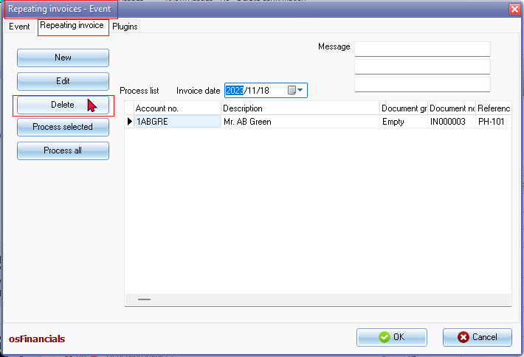

Click on Delete button and the item is removed from the "*Process list*".

**NOTE**

For events there is a confirmation message to delete the event

*Delete "Repeating invoices" from your schedule?  
This operation cannot be undone!*

#### Debtors / Creditors tab - Delete contact - No confirmation message

Click Delete button and gone is the contact

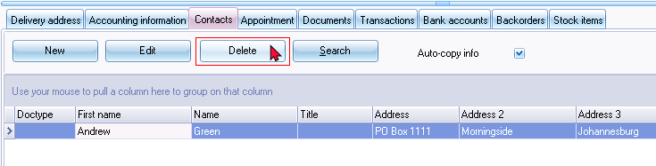

**NOTE**

On Contacts screen (**Default** ribbon) the Delete confirmation message is displayed:

*Do you want to delete this contactperson?*

On **Calendar - Contacts** screen the Delete confirmation message is displayed:

*Delete Ben Best from your list of contacts?  
This operation cannot be undone!*

#### Change Reporting groups 1 / Reporting group 2

Change Reporting groups 1 / Reporting group 2 for **Debtors** / **Creditors** and **Documents** no confirmation message is displayed from the context menu options on the grid.

Using the context menu on **Stock items** Change Reporting groups 1 / Reporting group 2 a confirmation message is displayed e.g.:

*Set reporting group 2*

**Budgets MSSQL Error**

Entering **Budgets** (**Reports** ribbon) and click on the **Apply to selection** button produces the following error:

*Incorrect syntax near 'a'.*

On **Setup → Accounts** you can enter budgets

**Access control**

***Posting / Delete buttons***

Need to update documentation

**Access control - Documents** tab - Document posting tick-box - Add **Posting** and **Delete** buttons to the Documents grid sidebar. Does not work for single users - Need to setup users before this Document posting will be available for a user.

It is just an entry in the database with user id 0

***Default language for a Set of Books***

In Firebird and MSSQL database types cannot change the language on **Setup → Access control** (System language) and click the **Apply** button as the default language for the Set of Books. It reverts back to the original language e.g. Afrikaans if you change it to English.

Workaround - You have to use the **Switch language** option on the **Start** ribbon to update the **System language** in **Setup Setup → Access control**.

Language can be set at user level. So user a can login with language a and user b with language b

In osFinancials5 / TurboCASH (453) the option was there and was used to set the System language without any users. Could also Set languages for users.

**System language** - Default language for the Set of Books

Language - Cannot select a language (empty / blank). You need to use the Multi-language Set of Books plugin ([Manual](https://www.osfinancials.org/en/plugin-manuals/515-multi-language-plugin) - [Shop](https://www.osfinancials.org/en/webshop/accountancy/multi-language-set-of-books) ) to select a language added in the [**Setup → Groups - Languages**](hnd-topic://ea415ae8eed341c98609503897aa45c6) reporting group.

**Access Violations - Reports**

***Ledger analyser - Balance sheet***

Produces Access violation error

*Access violation at address 525C8283 in module 'rtl290.bpl'. Read of address 2E300858*

Balance sheet prints after second attempt

***Graphs***

Some Graphs print Access violations click 1 or sometimes 2xtimes then it prints.

***Cost centres***

Cost centres were producing similar Access violation errors in the Balance sheet and some reports. Need to click 1 or more types then the report prints.

**Export - Accounts**

***Spreadsheet import - Accounts***

* Spreadsheet export import - No Sub-accounts Workaround delete accounts and recreate accounts.

* Export (Setup ribbon) Export tab txt file imports well - Need to delete the first tax account (No tax tab) and zero-rated items.

You can check the Tax percentages (User reports **→** Tax to see incorrect tax percentages such as the first Tax code (sub-account), which does not incluse a Tax tab and percentage.

***Import Stock***

Stock - Import - Tab-delimited .txt file

*The statement has been terminated. - Tab delimited *.txt file  
The INSERT statement conflicted with the FOREIGN KEY constraint "FK_DOCLINE_STOCK". The conflict occurred in database "MSSQL-TOETS-NUTSMAN", table "dbo.Stock", column 'WStockID'.*

Spreadsheet Export from Firebird databases and Import to MSSQL works.

**Imported Batches**

Replicated in both Firebird and MSSQL Database types.

**F8: Batch list** Empty accounts on the Unposted batch report.

Balancing the batch will print only the balanced accounts - need to reselect or confirm the imported accounts

Reselect the accounts - list on Batch **F8:List** Unposted batches report.

**Bank import - Import Bank statement**

***Delete Bank account with Posted transactions***

Bank statement - Import Account from spreadsheet - Cannot delete bank account

*The statement has been terminated.  
The DELETE statement conflicted with the REFERENCE constraint "FK_TRANSACT_ACCOUNT". The conflict occurred in database "MSSQL-MY-BOOKS", table "dbo.TransAct", column 'WAccountID'.*

If you have posted transactions to a bank account, you first need to cancel reverse posted batch and erase the batch to process the import bank statement

Similar errors in Firebird databases.

***Bank-Import Open Item link***

When allocating transactions for an Open item account, the Open item selection screen.

*The statement has been terminated.  
The INSERT statement conflicted with the FOREIGN KEY constraint "FK_OILINKSPRE_BATCH". The conflict occurred in database "MSSQL-MY-BOOKS", table "dbo.BatCon", column 'WBatchID'.*

**Imported Documents**

Document Export Import plugin used to export documents from a Set of Books (Firebird Database). Imported into a Set of Books (MSSQL database).

***Import Exported documents***

***Financial entry***

Financial Entry - Need to reselect the Ledger Account and confirm it is correct.

Can select a main account (with sub accounts).

Tax by default looks like the Tax is codes is correct, Tax amount on Documents grid - When opening the document the tax code may be blank. Need to select the correct tax code.

***Update Documents***

When updating documents, some errors were replicated in MSSQL databases. Some of these similar errors is replicated in Firebird databases.

*Fault in rounding please set your rounding margin document:AK000001 of 150  
You cant post to the zero tax account!*

Need to select the correct Tax account.

*AK000001 Algemene Grootboek 1000 0*

Financial Entry - Imported Documents - Need to select a Ledger account